# Robert F. Kennedy

**JUNE 2018 NEWSLETTER**

**Dear Parents and Guardians,**

**Summer has finally arrived!**

**This summer, the Providence School Department has partnered with the Providence Public Library, The Providence Community Library and Mayor Elorza’s office to offer the Passport to Summer Learning. This is a program for students entering Pre-K-Grade 5 to help mitigate summer learning loss.**

**Students have brought the passport home from school in a lanyard. It encourages families to explore the City and it’s cultural resources as well as shares City services such as water parks and pools as well as summer meals. If your child misplaced the passport, the information can be located at** [**www.provlib.org/passport**](http://www.provlib.org/passport)**.**

**Students are expected to complete the summer passport and return it to their school during the first week in September. Those that complete the passport will receive a prize from the school.**

**I hope that you have a wonderful vacation.**

**Sincerely,**

**Susan DeAthos**

**Susan DeAthos- Principal**

**Robert F. Kennedy Elementary**

**195 Nelson Street**

**Providence, RI 02908**

**(401)456-9403**

***Respect, Responsibility, Achievement, and Safety”***



***This newsletter is published in November, February and June.***

*Edited by: Richard Peters*

**PERFECT ATTENDANCE 3rd Q**

204

Victor Grier

Sofia Muhtaseb

Paul Ritualo

Destiny Starks

Brodie Zolkos

205

Valeri Barahona

Krystal De Jesus

Josue Flores Ramirez

Freddy Morales Sandoval

Eric Perreault

Jairo Quintanilla

Matthew Ryan

Mohammed Sulaiman

206

Trinity Dye

Jayden Ellerbe

Edward Fiallos Medina

Donovan Hanley

Samari Lee

Darien Vertyl

207

David Gorbey

209

Jonathan Alvarado

Javier Gallardo

Juan Luis Gutierrez

Joseph Mercedes

Xavier Muentes

210

Marvellous Awe

Carlos Inoa Baez

Edwin Gonzalez

Hertani Mane

Scarlett Soriano

211

Dean Finnin

Marieliz Ocasio

Askari Stefanidis

103

Oyinkansola Samuel

Diego Villanueva

104

Matthew Boyd

Issa Gueye

Janice Mercedes

Jazleri Reyes Torres

Jeancarlo Villanueva

105

Brighton Champagne

Wylie Derensis

Andrew Durand

Andersson Garcia Gonzalez

106

Nikoli Albarracin

Nathalia Domenech

Edwin Eesiah

Steven Gonzalez

Nyla Martin

Iliyah Mola

Jordan Perez

Alexander Seri

Kyara Solano

109

Eminson Jimenez Zavala

Alice Maryanov

Henry Nguyen

Robert Quintanilla

110

Renata Berrios Ruiz

Jaiden Cox

Starlyn Gomez

Sylvestine Howard

Nichloas Jasinski

111

Amar’e Beasley

Annalia Bowden

Aissatou Diouf

Sciara Gorbey

Jair Medina

Russell Sanchez de Lozada

Avery Walker

112

Preston Bartley

Joeali Cuevas

Isabell Hoy

Giselle Machuca

Kevin Morales

Mariah Reynoso Avilez

Aaron Sionni

113

Nyla Gomez

Xavier Ortiz

114

Jessica Albert

Macsen Lin

Yaelin Rodriguez

Sulaf Sulaiman

Christian Tornez

Jodie Weng

201

Noah Johnson

Hazel Labelle

Keiko Lavendier

Corey-Lee Rezendes

Anabel Santana

Dylan Santana

Aaralyn Scott

Jake Temporal

203

Jeremy Calcagno

Rosemary Donovan

Isaiah Estrada

Josiah Garcia

Miranda Lin

Tylena Taing

Lily Temporal

**Here we are in Room 205 listening to Miss Lily talk about art and our visit to RISD.**

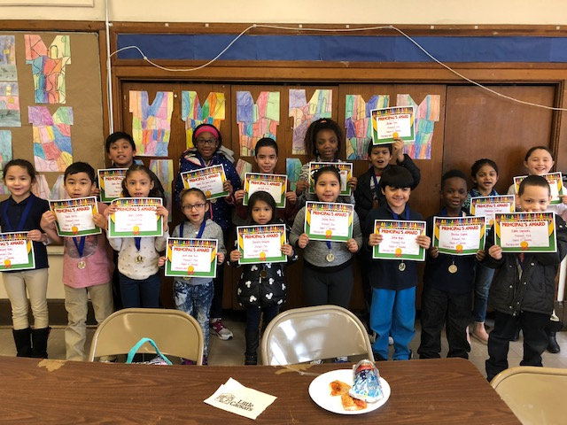

**Principal’s Club February**

**Jazleri Reyes Torres**

**Doris Daniela Vasquez**

**Dylan Coleman**

**Jostin Reyes**

**Joeali Cuevas**

**Prestyn Eugene**

**Mackenzie Haz**

**Jayline Perez**

**Maahnoor Siddiqui**

**Keiko Lavendier**

**Jorllyk Cruz**

**Anayah Boga**

**Eddie Gonzalez**

**Juan Jose Luis Gutierrez**

**Marvellous Awe**

**Thaili Perry**

**Daysi De Leon Clarke**

**Melissa Oyedele**

**Jordan Sivo**

**Principal’s Club March**

**Janice Mercedes**

**Eminson Jimenez**

**Emmanuel Estrada Pinero**

**Sylvestine Howard**

**Ge’Liyha Ellerbe**

**Nicolas Mejia**

**Christopher Britto**

**Christian Torres**

**Andrew Durand**

**Lucas Jakubowski**

**Noah Johnson**

**Umutesse Saidi**

**Azhenee McLean**

**Xavier Muentes**

**Hunter Walker**

**Yadira Solis-Figueroa**

**Diego Villanueva**

**Miranda Lin**

**Destiny Starks**

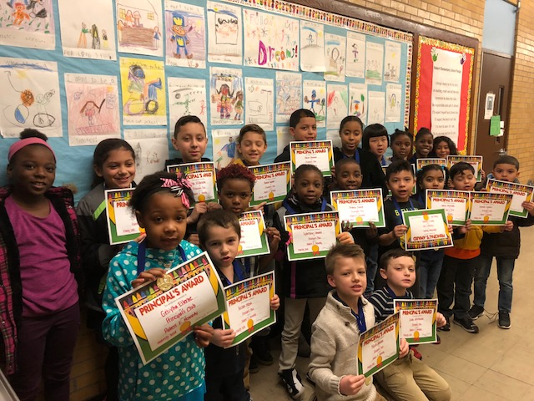

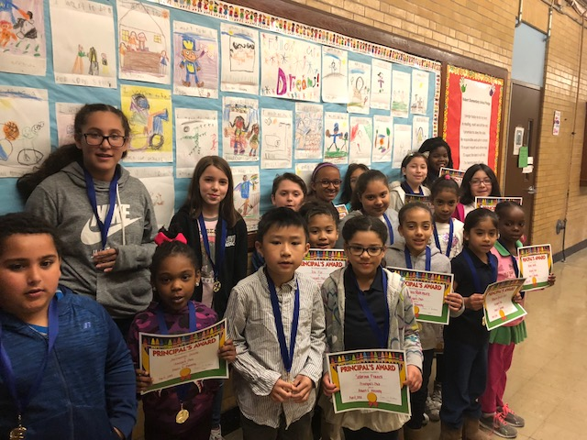

**Principal’s Club May**

**David Delomba**

**Henry Nguyen**

**Nicholas Jasinski**

**Jair Medina**

**Mariah Reynoso Avilez**

**Isabella Luna**

**Angel Torres**

**Kailyn Olivo**

**Alexa Krum**

**Alijah Camacho**

**Anabel Santana**

**Virginia Donovan**

**Donovan Hanley**

**Makai Brand**

**Eduardo Familia**

**Hertani Mane**

**Gabriella Carbone**

**Stacy Pineda**

**Kiana Rodriguez**

**Angely Perez**

**Jaloni Pope-Colebut**

**Principal’s Club April**

**Jaz’marelis Oviedo**

**Nema Saidi**

**Renata Berrios Ruiz**

**Dai-nghia Le**

**Jola Fox**

**Camila Mora**

**Sabrina Franco**

**Zara Alvarez**

**Josiah Vazquez**

**Deiani Rodriguez**

**Elizabeth Duefield**

**Mikala Hernandez Vega**

**David Gorbey**

**Ashley Pineda Abadia**

**Lilialis Perez**

**Alivia Toe**

**Janessa Martin**

**Rosemary Donovan**

**Sofia Muhtaseb**

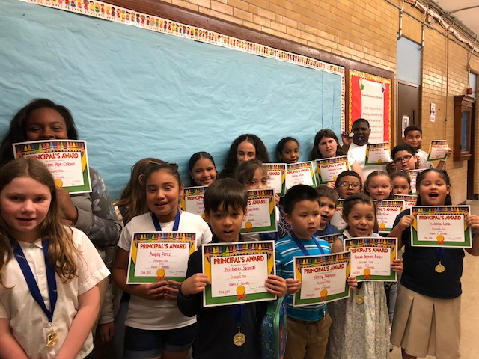

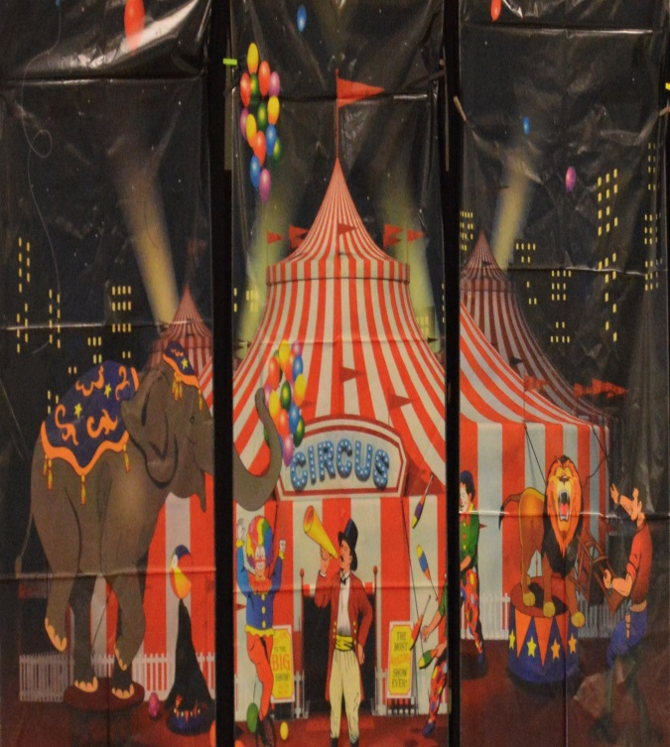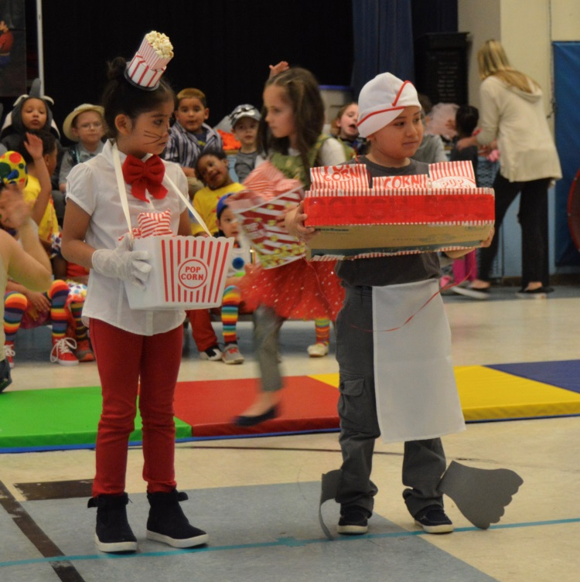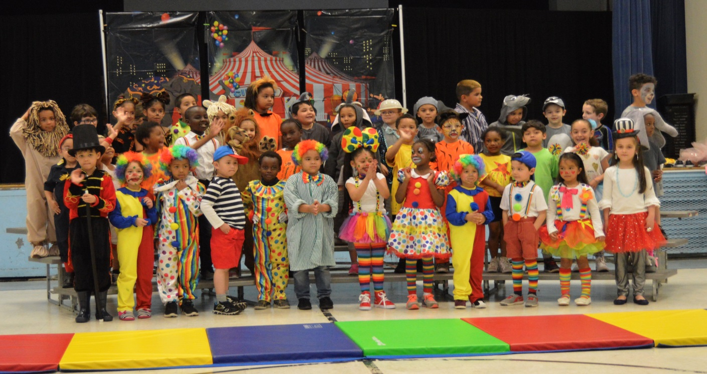

**K-110 and K-109 put on a fabulous circus show for their friends and families.  A great time was had by all!**

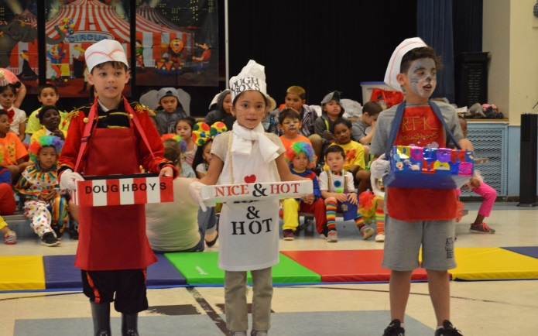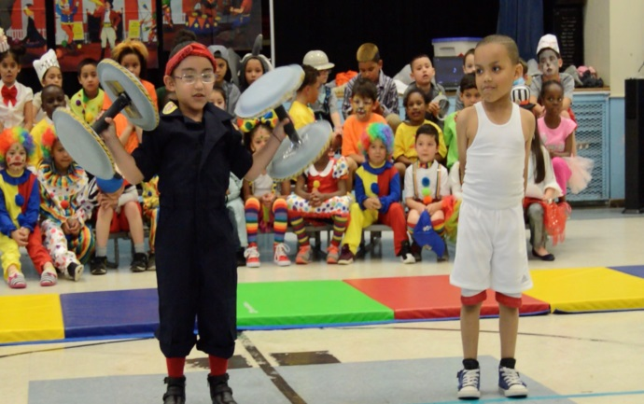

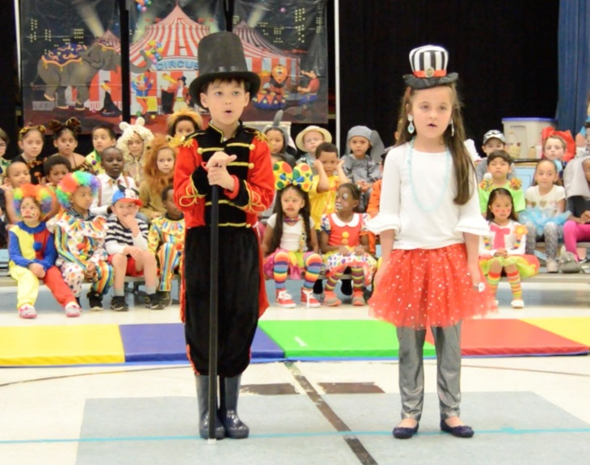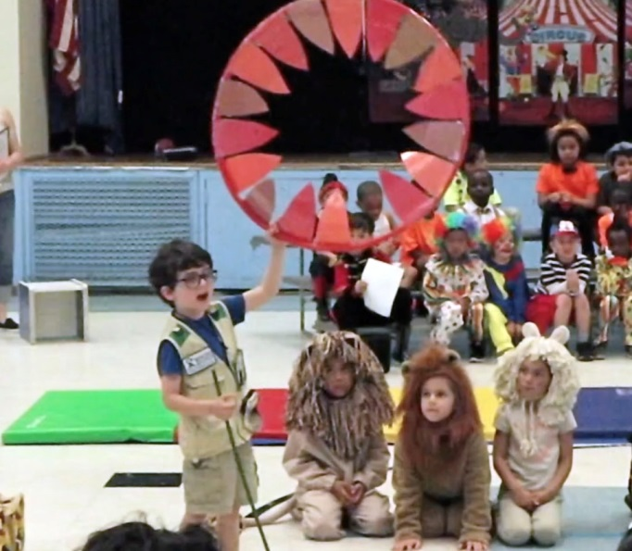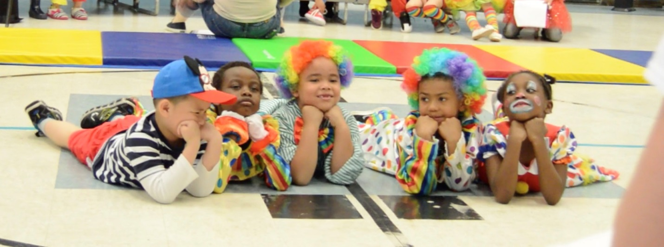

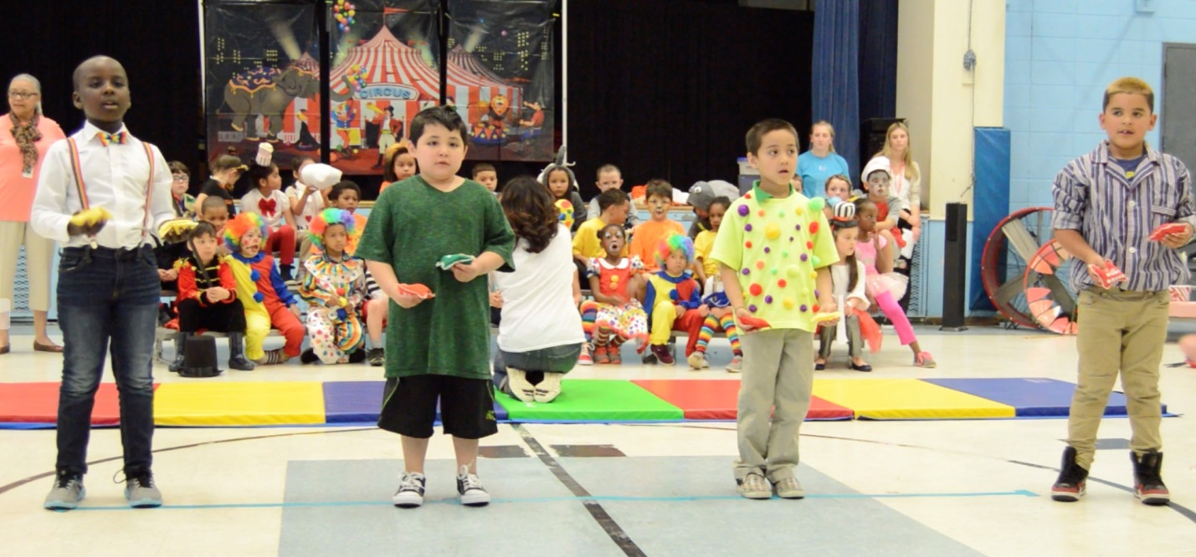

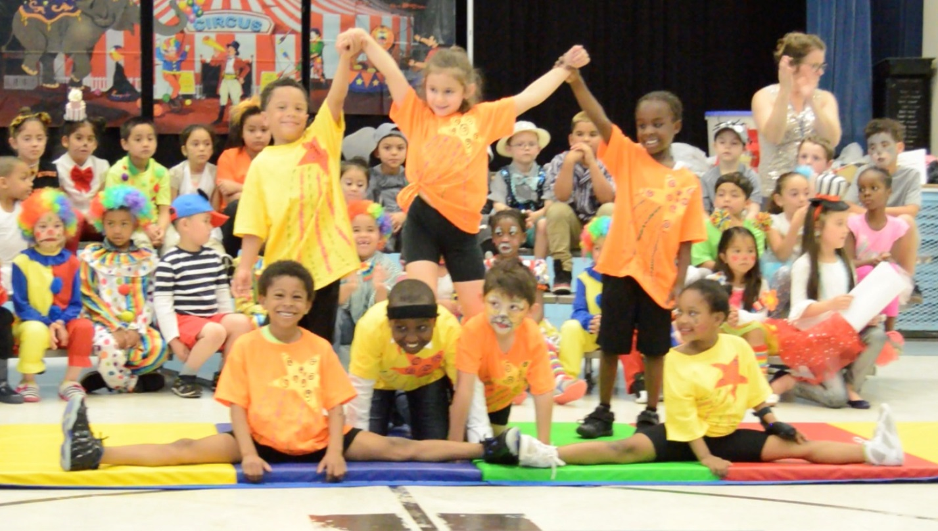



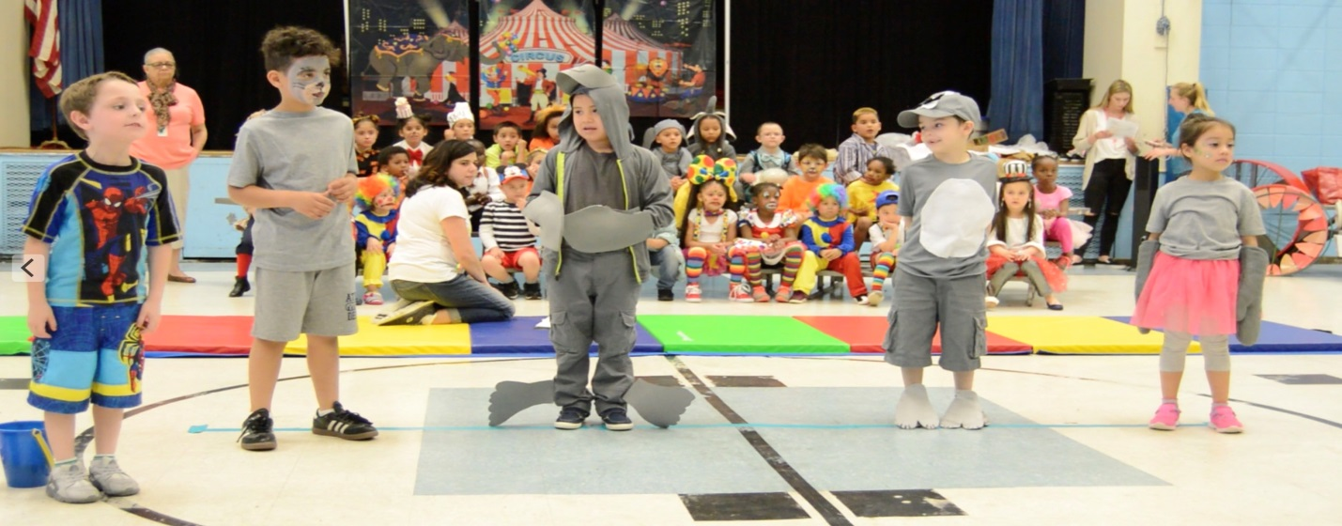

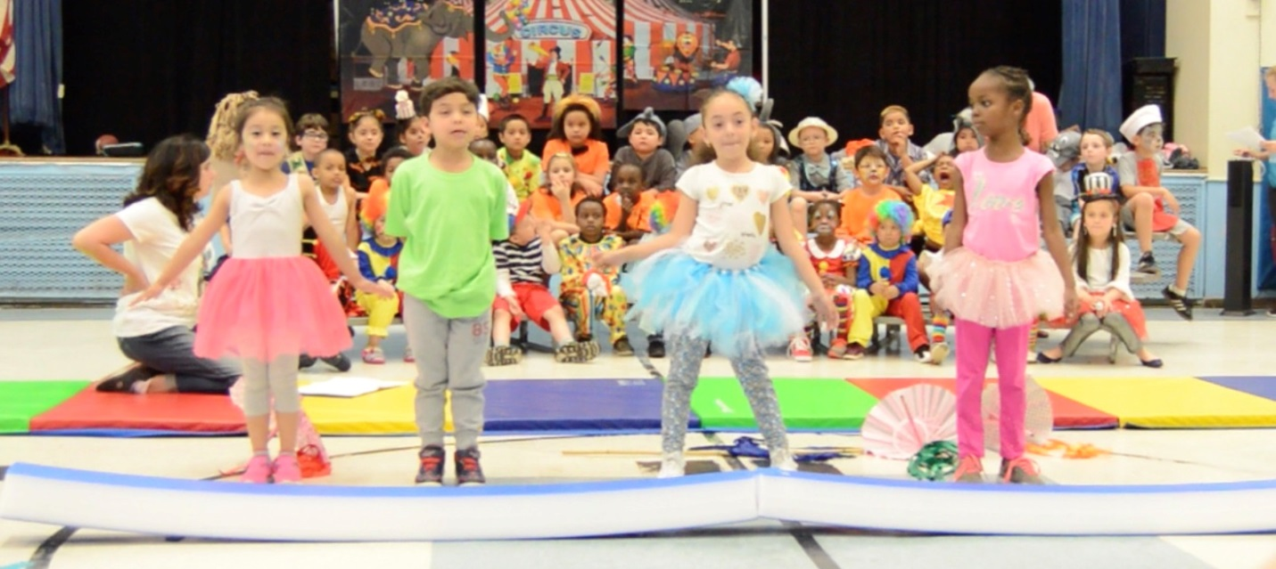

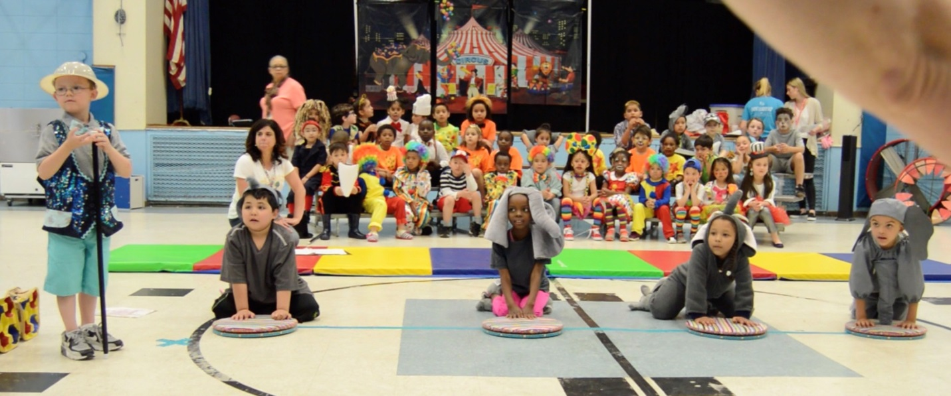

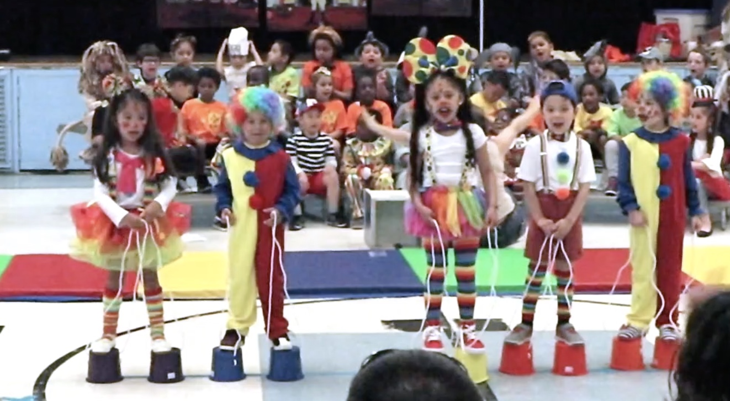

**MRS. COELHO--CHANCE TO DANCE**

**This year 29 students from grades 3-5 participated in the Chance to Dance program on Fridays during the school's enrichment time.  A choreographer from the program came in each week to teach the two dances the students would perform for the show.**

**On May 22, the students performed their dances on a professional stage at the Providence Performing Art Center for family and friends. It was so nice to see our talented students shine!**

**Fourth grade student, Jeniyah Bonafiglia represented Robert F. Kennedy School by performing along with a select group of students from the various schools involved. This group is called Sleeque Feet. Sleeque Feet members go to extra practices outside of school and not only perform two extra dances during the show but perform for a few community events.**

**Chance to Dance is open to students in grades 3-5.  The program will start up again in the fall for those students interested.**

**Michael Reed posing as a reporter for Animal Planet while presenting his animal research project. Room 211**

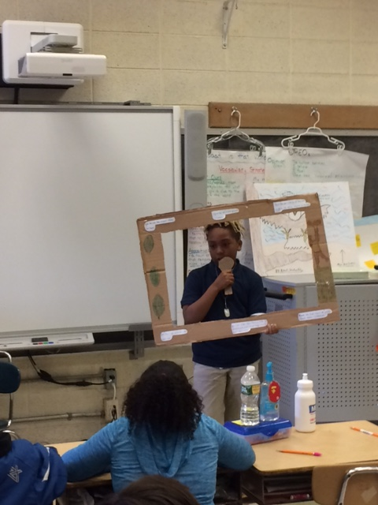

Mrs. Andreozzi, Ms. Voccio, Mrs. Aubin, Mrs. Ricci, Ms. Trout, Mrs. Medeiros, Mrs. Bucci and Ms. Haggerty have been working on projects that help students communicate more about mathematics. Here are some pictures of the work they are doing.

Ms. Haggerty-***Math Coach to the "STARS"***



